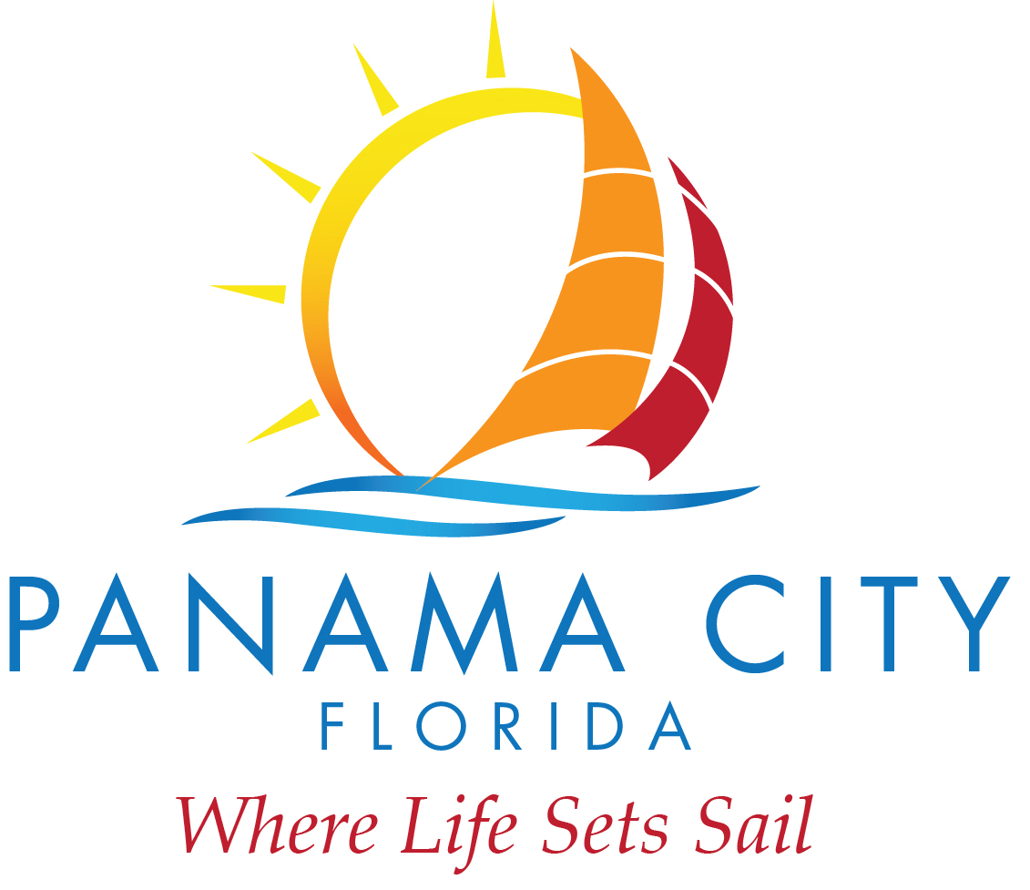
DESTINATION PANAMA CITY
REGULARLY SCHEDULED QUARTERLY MEETING
November 26, 2019
9:00 A.M. (approx. – immediately following schedule City of Panama City meetings)
840 West 11th Street, Panama City, FL 32401
Commission Chambers

- Roll Call – Chairman Haligas and board members Greg Brudnicki, Mike Nichols, Kenneth Brown, Billy Rader, Nirav Banker, and Jennine Brown were all in attendance.
- Marketing Presentations were presented by teams from bcf and Fahlgren Mortine. After the presentations, the board discussed the pros and cons of each presentation, the impactfulness of the presentations, and what their personal opinions as to which firm would work best with the Destination Panama City. A motion to authorize CEO Vigil to negotiate a contract with Fahlgren Mortine was made by Nichols and seconded by Haligas. Vote was unanimous.
- CEO Vigil stated should would set a target date of December 10, 2019 for bringing an acceptable contract back to the board with and authorization to execute request.

