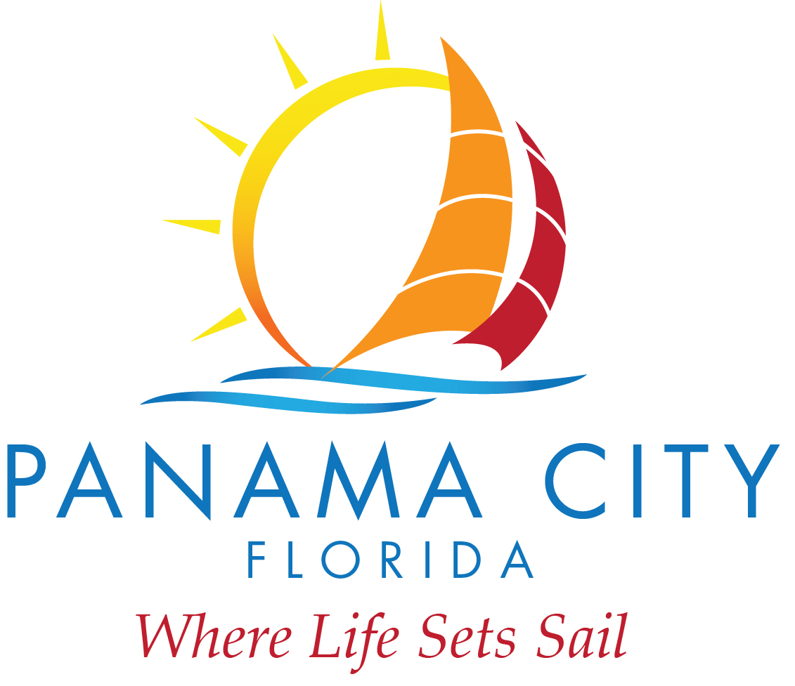

DESTINATION PANAMA CITY
REGULARLY SCHEDULED QUARTERLY MEETING
December 10, 2019
9:00AM (approximate time, follows City Commission Meeting)

- Roll Call in attendance were Chairman Haligas and board members Greg Brudnicki, Mike Nichols, Billy Rader, Kenneth Brown, Nirav Banker and Jennine Brown.
- CEO Vigil presented the negotiated marketing agency of record agreement between Destination Panama City and Fahlgren Mortine. Board member Brudnicki motioned to authorize CEO Vigil to execute the contract. Board Member Banker seconded the motion. Vote was unanimous.
- There was no public comment.
- Meeting was adjourned.

