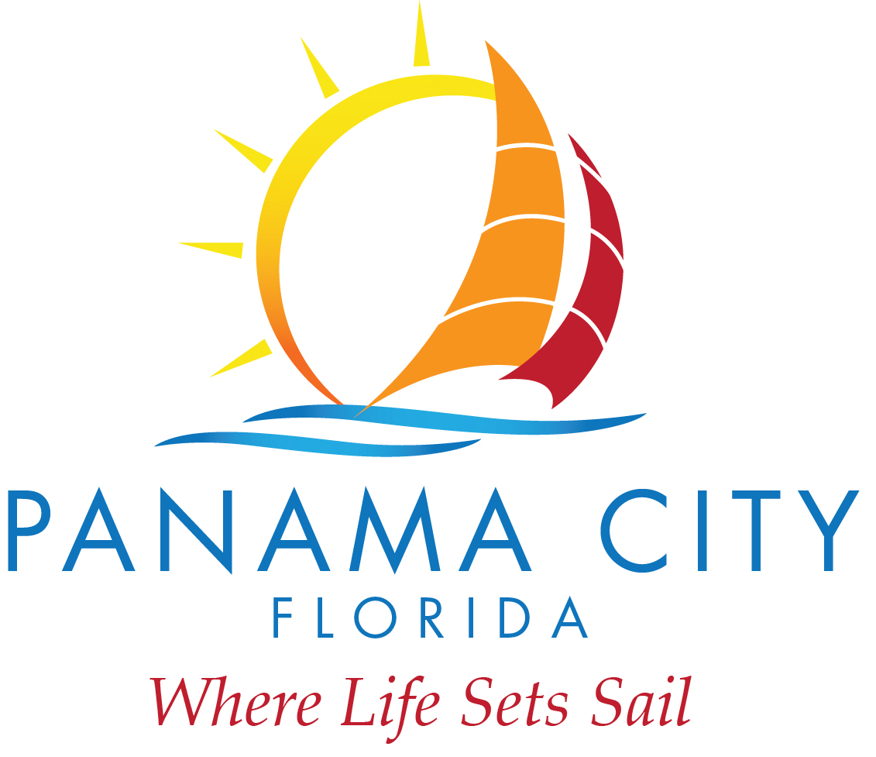
DESTINATION PANAMA CITY
SCHEDULED MEETING
October 22, 2019
9:00 A.M. (approximately)
Bay County Government Complex
840 West 11th Street, Panama City, FL 32401

- Roll Call – Chairman Jenna Haligas and Board Members Greg Brudnicki, Mike Nichols, Billy Rader, Kenneth Brown, and Nirav Banker were all present for the meeting.
- Motion to accept the Minutes of 07/19/19 was made by Brudnicki and seconded by Brown. Vote was unanimous.
- Motion to accept Financial Report Period Ending 8/31/2019 was made by Brudnicki and seconded by Nichols. Vote was unanimous.
- Motion to accept Tourist Development Tax Report as presented was made by Rader and seconded by Brown. Vote was unanimous.
- Motion to authorize CEO Vigil to extend and invitation to formally present marketing agency of record was made by Nichols and seconded by Haligas. Vote was unanimous.
- Motion to authorize CEO Vigil to bring Land Lease for future Visitors Center to City Administration for negotiation regarding section 7.1 Rent with final agreement brought back to the board for approval by Nichols and seconded by Rader. Vote was unanimous.
- Motion to authorize CEO Vigil to engage Anchor CEI for drafting Design-Build RFP for new multi-use Visitors Center made by Brudnicki and seconded by Brown. Vote was unanimous.
- After review and discussion of CEO Performance Evaluation for Jennifer Vigil, a motion was made to approve a 3% salary raise with a one-time 7% bonus by Nichols and seconded by Rader. Vote was unanimous.
- CEO Vigil briefed the board regarding the topics of pole banner designers, gateway signage, short term rental business license requirements and board compositions and by-laws. No action was required on the items.
- CEO Vigil announced the upcoming events, no action was required.
- CEO Vigil requested the board approve the date of Nov 26, 2020 as the date for Marketing Agency formal presentations. Request approved by Banker and seconded by Nichols. Vote was unanimous.

Meeting adjourned.

